Listening
SECTION 1 Questions 1-10

Questions 1-5
Complete the form below.

Write NO MORE THAN THREE WORDS AND/OR A NUMBER for each answer.

§
Example Answer
Aim: protecting environment through recycling

Types of group: non-profit
Frequency of newspaper collection: 1.........................
Name: 2.........................
Address: 3.........................
E-mail: 4..........................
Postcode: 5..........................

Questions 6-10
Complete the form below.

Recycling
Ways of recycling | Newspaper:in a 6.................... box
Nearest rubbish collection center | On the East Side of 7 .................
Rubbish that can be recycled | Blues box: 8 .................  Green box: glass and plastics  Yellow box: paper
Rubbish that cannot be recycled | 9.................
Name of a booklet | 10..............

SECTION 2 Questions 11-20

Questions 11-15
Complete the notes below.
Write NO MORE THAN TWO WORDS AND/OR A NUMBER for each answer.

Public Service Broadcast
Volunteer workers should be at least 11 ............ years old.
Job application should not have 12 ....................
Job applications are asked to submit 13.............. and 14...................
The employers will pay the expenses of 15.................. and phone calls.
Questions 16-18
Complete the table below.

Write NO MORE THAN TWO WORDS for each answer.

TYPE OF PEOPLE | DUTIES | SERVICE TIME
Wheelchair Users | Drive them in volunteer’s  16.................... to view nature | Tuesday afternoons
The Blind | Read books to them | 17.........................
Disabled Children | Take care of them on holidays | For one week in 18................

Questions 19-20
Complete the notes below.
Write NO MORE THAN THREE WORDS AND/OR A NUMBER for each answer.
If you are willing to become a volunteer, here is some information to help:
Contact Person: Mary Smith
Post Office Box: 19..................
E-mail Address: 20...................

Section 3 Questions 21-30

Questions 21-30
Choose the correct letter, A, B, or C.

The “Returning Students Advisor” Consultation

21 What does the man want to have?

A a break
B a talk
C a class

22 What does the man think of children nowadays?

A confident
B intelligent
C mature

23 What type of people does the man want to teach?

A children
B students
C adults

24 What did the man do when he encountered former students?

A had a conversation
B ran away
C taught them

25 What is the man’s greatest weakness?

A old-fashioned
B lack of confidence
C introversive

26 When did the Doctor go to college?

A 18 years ago.
B Before starting a family.
C When she was 35 years old.

27 How did the woman feel when she was a freshman?

A hopeless
B unsuccessful
C stressed

28 How does the man feel about his career?

A unique
B boring
C impressive

29 What does the man finally decide to study?

A Languages
B Business
C Liberal Arts

30 Which change in students’ life is NOT important to Frank?

A classroom technology
B student housing
C University facilities

Section 4 Questions 31-40

Questions 31-32
Choose the correct letter, A, B, or C.

31 Bees that help with pollination benefit flowers and

A female plants only.
B pollen.
C fruit trees.

32 Bees produce wax that can be made into candles and

A honey.
B polish.
C pollen.

Questions 33-38
Complete the sentences below.

Write NO MORE THAN THREE WORDS for each answer.

33 Dragonflies eat ...........................
34 Insects can be harmful because they can carry diseases like malaria and .................
35 Harmful insects may destroy crops, clothes, furniture, and even the.....................

Chemical solutions to insect problems often are not worthwhile because:

36 They are effective on a .........................
37 They can bring harm to ............................
38 Insects become ........................ to the chemicals quickly.

Question 39

Choose the correct letter, A, B, or C.

39 Biological methods are .......................... than chemical methods of eliminating insects.

A more harmful
B more costly
C cheaper

Question 40
Complete the sentences below.
Write NO MORE THAN TWO WORDS for each answer.

40 In order to control the breeding of insects, one needs to understand the insects’............................

This page is intentionally left blank.
READING
READING PASSAGE 1

You should spend about 20 minutes on Questions 1-13, which are based on Reading Passage 2 below.
Questions 1-6
The reading passage has seven paragraphs, A-G.
Choose the correct heading for paragraphs B-G from the list below
Write the correct number, i-x, in boxes 1-6 on your answer sheet.

List of Headings
i Low probability triggers unpersuasive findings
ii Understanding of intelligence remains limited
iii Difficulty in accurately defining intelligence
iv People with high IQ seldom fall sick
v An innovative appliance to improve the probe
vi The financial cost of a new research
vii Why an indicator is imperfect but referable
viii Genes mean extra when compared with environment
ix A vital indicator for kids' intelligence performance
x Multiple factors involved in intelligence

Example Answer
Paragraph A ix

1 Paragraph B
2 Paragraph C
3 Paragraph D
4 Paragraph E
5 Paragraph F
6 Paragraph G

The Research for Intelligence

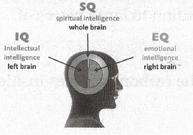
A In Robert Plomin's line of work, patience is essential. Plomin, a behavioral geneticist at the Institute of Psychiatry in London, wants to understand the nature of intelligence. As part of his research, he has been watching thousands of children grow up. Plomin asks the children questions such as "What do water and milk have in common?" and "In what direction does the sun set?" At first he and his colleagues quizzed the children in person or over the telephone. Today many of those children are in their early teens, and they take their tests on the Internet. In one sense, the research has been a rousing success. The children who take the tests are all twins, and throughout the study identical twins have tended to get scores closer to each other than those of non-identical twins, who in turn have closer scores than unrelated children. These results - along with similar ones from other studies - make clear to the scientists that genes have an important influence on how children score on intelligence tests.

B But Plomin wants to know more. He wants to find the specific genes that are doing the influencing. And now he has a tool for pinpointing genes that he could not have even dreamed of when he began quizzing children. Plomin and his colleagues have been scanning the genes of his subjects with a device called a micro-array, a small chip that can recognize half a million distinctive snippets of DNA. The combination of this powerful tool with a huge number of children to study meant that he could detect genes that had only a tiny effect on the variation in scores.

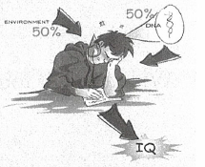
C Still, when Plomin and his co-workers unveiled the results of their micro-array study—the biggest dragnet for intelligence-linked genes ever undertaken—they were underwhelming. The researchers found only six genetic markers that showed any sign of having an influence on the test scores. When they ran stringent statistical tests to see if the results were flukes, only one gene passed. It accounted for 0.4 percent of variation in the scores. And to cap it all off, no one knows what the gene does in the body. "It's a real drag in some ways," Plomin says.

D Plomin's experience is a typical one for scientists who study intelligence. Along with using micro-arrays, they are employing brain scans and other sophisticated technologies to document some of the intricate dance steps that genes and environment take together in the development of intelligence. They are beginning to see how differences in intelligence are reflected in the structure and function of the brain. Some scientists have even begun to build a new vision of intelligence as a reflection of the ways in which information flows through the brain. But for all these advances, intelligence remains a profound mystery. "It's amazing the extent to which we know very little," says Johnson, a psychologist at the University of Minnesota.

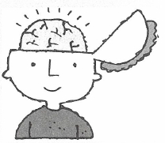
E In some ways, intelligence is very simple. "It's something that everybody observes in others," says Eric Turkheimer of the University of Virginia. Everybody knows that some people are smarter than others, whatever it means technically. It's something you sense in people when you talk to them." Yet that kind of gut instinct does not translate easily into a definition. In 1996 the American Psychological intelligence a scientific Association issued a report on, which stated only that "individuals differ from one another in their ability to understand complex ideas, to adapt effectively to the environment, to learn from experience, to engage in various forms of reasoning, to overcome obstacles by taking thought."

F To measure these differences, psychologists in the early 1900s invented tests of various kinds of thought, such as math, spatial reasoning and verbal skills. To compare scores on one type of test to those on another, some psychologists developed standard scales of intelligence. The most familiar of them is the intelligence quotient, which is produced by setting the average score at 100. IQ scores are not arbitrary numbers, however. Psychologists can use them to make strong predictions about other features of people's lives. It is possible to make reasonably good predictions, based on IQ scores in childhood, about how well people will fare in school and in the workplace. People with high IQs even tend to live longer than average. "If you have an IQ score, does that tell you everything about a person's cognitive strengths and weaknesses? No," says Richard J. Haier of the University of California, Irvine. But even a simple number has the potential to say a lot about a person. "When you go see your doctor, what's the first thing that happens? Somebody takes your blood pressure and temperature. So you get two numbers. No one would say blood pressure and temperature summarize everything about your health- but they are key numbers."

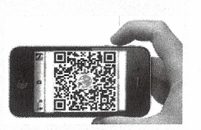
G Then what underlies an intelligence score? "It's certainly tapping something," says Philip
Shaw, a psychiatrist at the National Institute of Mental Health (NIMH). The most influential theory of what the score reflects is more than a century old. In 1904 psychologist Charles Spearman observed that people who did well on one kind of test tended to do well on others. The link from one score to another was not very tight, but Spearman saw enough of a connection to declare that it was the result of something he called a g factor, short for general intelligence factor. How general intelligence arose from the brain, Spearman could not say. In recent decades, scientists have searched for an answer by finding patterns in the test scores of large groups of people. Roughly speaking, there are two possible sources for these variations. Environmental influences-anything from the way children are raised by their parents to the diseases they may suffer as they develop-are one source. Genes are another. Genes may shape the brain in ways that make individuals better or worse at answering questions on intelligence tests.

Questions 7-10
Use the information in the passage to match the people (listed A-G) with opinions or deeds below. Write the appropriate letters A-G in boxes 7-10 on your answer sheet.
A Plomin
B Philip Shawn
C Eric Turkheimer
D Charles Spearman
E Richard J. Haier
F Wendy Johnson
7 A full conclusion can be hardly reached just by the one example in IQ test.
8 It is not easy to exclude the occasionality existed in the research.
9 Humans still have more to explore in terms of the real nature of intelligence.
10 It is quite difficult to find the real origins where the general intelligence comes.

Questions 11-13
Summary
Complete the following summary of the paragraphs of Reading, using no more than three words from the Reading Passage for each answer. Write your answers in boxes 11-13 on your answer sheet.

Many researchers including Plomin have faced with the typical challenge when ..........11......... are implemented. They try to use all possible methods to record certain ..........12.........performed both by genes and environment which contributes to the progress of intelligence. The relationship between intelligence and brain become their targeted area. What's more, according to some researchers intelligence is regarded to be ..........13......... of how messages transmit in the brain.

READING PASSAGE 2

You should spend about 20 minutes on Questions 14-26, which are based on Reading Passage 2 below.
Does An IQ Test Prove Creativity?
Everyone has creativity, some a lot more than others. The development of humans, and possibly the universe, depends on it. Yet creativity is an elusive creature. What do we mean by it? What is going on in our brains when ideas form? Does it feel the same for artists and scientists? We asked writers and neuroscientists, pop stars and AI gurus to try to deconstruct the creative process - and learn how we can all ignite the spark within.

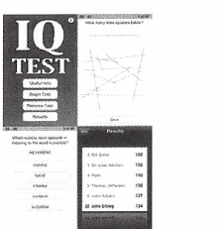
A In the early 1970s, creativity was still seen as a type of intelligence. But when more subtle tests of IQ and creative skills were developed in the 1970s, particularly by the father of creativity testing, Paul Torrance, it became clear that the link was not so simple. Creative people are intelligent, in terms of IQ tests at least, but only averagely or just above. While it depends on the discipline, in general beyond a certain level IQ does not help boost creativity; it is necessary, but not sufficient to make someone creative.

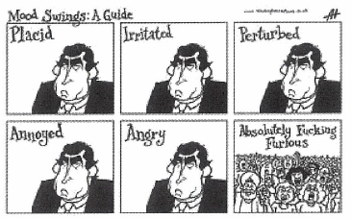
B Because of the difficulty of studying the actual process, most early attempts to study creativity concentrated on personality. According to creativity specialist Mark Runco of California State University, Fullerton, the "creative personality" tends to place a high value on aesthetic qualities and to have broad interests, providing lots of resources to draw on and knowledge to recombine into novel solutions. "Creatives" have an attraction to complexity and an ability to handle conflict. They are also usually highly self-motivated, perhaps even a little obsessive. Less creative people, on the other hand, tend to become irritated if they cannot immediately fit all the pieces together. They are less tolerant of confusion. Creativity comes to those who wait, but only to those who are happy to do so in a bit of a fog.

C But there may be a price to pay for having link has been made between creativity and a creative personality. For centuries, a link has been made between creativity and mental illness. Psychiatrist Jamison of Johns Hopkins University in Baltimore, Maryland, found that established artists are significantly more likely to have mood disorders. But she also suggests that a change of mood state might be the key to triggering a creative event, rather than the negative mood itself. Intelligence can help channel this thought style into great creativity, but when combined with emotional problems, lateral, divergent or open thinking can lead to mental illness instead.

D Jordan Peterson, a psychologist at the University of Toronto, Canada, believes he has identified a mechanism that could help explain this. He says that the brains of creative people seem more open to incoming stimuli than less creative types. Our senses are continuously feeding a mass of information into our brains, which have to block or ignore most of it to save us from being snowed under. Peterson calls this process latent inhibition, and argues that people who have less of it, and who have a reasonably high IQ with a good working memory can juggle more of the data, and so may be open to more possibilities and ideas. The downside of extremely low latent inhibition may be a confused thought style that predisposes people to mental illness. So for Peterson, mental illness is not a prerequisite for creativity, but it shares some cognitive traits.

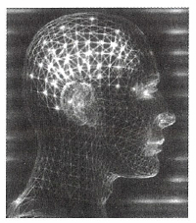
E But what of the creative act itself? One of the first studies of the creative brain at work was by Colin Martindale, a psychologist from the University of Maine in Orono. Back in 1978, he used a network of scalp electrodes to record an electroencephalogram, a record of the pattern of brain waves, as people made up stories. Creativity has two stages: inspiration and elaboration, each characterised by very different states of mind. While people were dreaming up their stories, he found their brains were surprisingly quiet. The dominant activity was alpha waves, indicating a very low level of cortical arousal: a relaxed state, as though the conscious mind was quiet while the brain was making connections behind the scenes. It's the same sort of brain activity as in some stages of sleep, dreaming or rest, which could sleep and relaxation can help people be creative. However, quiet-minded people were asked to work on their stories, the alpha wave activity dropped off and the brain became busier, revealing increased cortical arousal, more corralling of activity and more organised thinking. Strikingly, it was the people who showed the biggest difference in brain activity between the inspiration and development stages who produced the most creative storylines. Nothing in their background brain activity marked them as creative or uncreative. "It's as if the less creative person can't shift gear," says Guy Claxton, a psychologist at the University of Bristol, UK. "Creativity requires different kinds of thinking. Very creative people move between these states intuitively." Creativity, it seems, is about mental flexibility: perhaps not a two-step process, but a toggling between two states. In a later study, Martindale found that communication between the sides of the brain is also important.

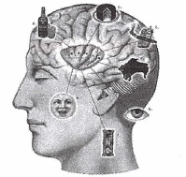
F Paul Howard-Jones, who works with Claxton at Bristol, believes he has found another aspect of creativity. He asked people to make up a story based on three words and scanned their brains using functional magnetic resonance imaging. In one trial, people were asked not to try too hard and just report the most obvious story suggested by the words. In another, they were asked to be inventive. He also varied the words so it was easier or harder to link them. As people tried harder and came up with more creative tales, there was a lot more activity in a particular prefrontal brain region on the right-hand side. These regions are probably important in monitoring for conflict, helping us to filter out many of the unhelpful ways of combining the words and allowing us to pull out just the desirable connections, Howard-Jones suggests. It shows that there is another side to creativity, he says. The story-making task, particularly when we are stretched, produces many options which we have to assess. So part of creativity of process of evaluating is a conscious analysing ideas. The test also shows that the more we try and are stretched, the more creative our minds can be.

G And creativity need not always be a solitary, tortured affair, according to Teresa Amabile of Harvard Business School. Though there is a slight association between solitary writing or painting and negative moods or emotional disturbances, scientific creativity and workplace creativity seem much more likely to occur when people are positive and buoyant. In a decade-long study of real businesses, to be published soon, Amabile found that positive moods relate positively to creativity in organisations, and that the relationship is a simple linear one. Creative thought also improves people's moods, her team found, so the process is circular. Time pressures, financial pressures and hard-earned bonus schemes on the other hand, do not boost workplace creativity: internal motivation, not coercion, produces the best work.

H Another often forgotten aspect of creativity is social. Vera John-Steiner of the University of New Mexico says that to be really creative you need strong social networks and trusting relationships, not just active neural networks. One vital characteristic of a highly creative person, she says, is that they have at least one other person in their life who doesn't think they are completely nuts.

Questions 14-17
Do the following statements agree with the information given in Reading Passage 2?

TRUE if the statement is true
FALSE if the statement is false
NOT GIVEN if the information is not liven in the passage

14 High IQ guarantees more ability to create in one person than one with an average score.
15 For a competitive society, individuals' language proficiency is more important than the other abilities.
16 A wider range of resources and knowledge can be integrated into bringing about creative approaches.
17 A creative person not necessarily suffers more mental illness.

Questions 18-22
Use the information in the passage to match the people (listed A-F) with opinions or deeds below. Write the appropriate letters A-F in boxes 18-22 on your answer sheet.

A Jamison
B Jordan Peterson
C Guy Claxton
D Howard-Jone
E Teresa Amabile
F Vera Tohn-Steiner

18 Instead of producing the negative mood, a shift of mood state might be the one important factor of inducing a creative thinking.
19 Where the more positive moods individuals achieve there is higher creativity in organizations.
20 Good interpersonal relationship and trust contribute to a person with more creativity
21 Creativity demands different kinds of thinking that can be easily changed back and forth.
22 Certain creative mind can be upgraded if we are put into more practice in assessing and processing ideas.

Questions 23-26
Summary
Complete the summary paragraph described below. In boxes 23-26 on your answer sheet, write the correct answer with no more than three words.

But what of the creative act itself? In 1978, Colin Martindale made records of pattern of brain waves as people made up stories by applying a system constituted of many .…23.…. Two phrases of mind state such as .…24.… are found. While people were still planning their stories, their brains shows little active sign and the mental activity was showing a very relaxed state as the same sort of brain activity as in sleep, dreaming or relaxing. However, experiment proved the signal of.....25.…went down and the brain became busier revealing increased cortical arousal, when these people who are in a laidback state were required to produce their stories. Strikingly, it was found the more.....26.…in brain activity between two stages, the more creative storylines people produced.
READING PASSAGE 3

You should spend about 20 minutes on Questions 27-40, which are based on Reading Passage 2 below.
Sir Francis Ronalds and Telegraph

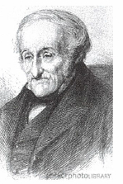
A RONALDS, Sir FRANCIS (1788-1873), inventor of the electric telegraph and meteorologist, son of Francis Ronalds, a London merchant, and of his wife, Jane, daughter of William Field, was born in London on 21 Feb. 1788. Ronalds was educated at a private school at Cheshunt by the Rev. E. Cogan. At an early age he displayed a taste for experiment, and he acquired great skill later in practical mechanics and draughtsmanship. Under the influence of Jean Andre de Luc (1727-1817), whose acquaintance he made in 1814, he began to devote himself to practical electricity. In 1814 and 1815 he published several papers on electricity in Tilloch's 'Philosophical Magazine,' one of which records an ingenious use of De Luc's `electric column as a motive power for a clock.

B Ronalds's name is chiefly remembered as the inventor of an electric telegraph. Since 1753, when the first proposal for an electric telegraph worked by statical electricity was made by a writer signing `C. M.' (said to be Charles Morrison) in the 'Scots Magazine', successive advances had been made abroad by Volta, Le Sage, Lomond, Cavallo, Salva, and others; but much was needed to perfect the invention.

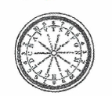
C In 1816 Francis Ronalds, then living at Upper Mall, Hammersmith, built in his back garden two frames to accommodate eight miles of wire for his new invention of an electrostatic telegraph. It used clockwork-driven rotating dials，engraved with letters of the alphabet and numbers, with each other, at both ends of the circuit. For the past three or four years, encouraged by the octogenarian Swiss meteorologist, Jean Andre De Luc, Ronalds had been enthusiastically experimenting with electrostatic clockwork devices. When someone desired to send a message he earthed the wire at his end at the moment when the dial indicated the desired letter. At the receiving end the pith balls would fall together when earthed and the recipient noted the letter showing on his dial at that moment. The system was slow and depended on the two dials staying in step, but Ronalds successfully transmitted and letters over 150 metres of wire; later he succeeded in sending received messages through eight miles of iron wire suspended above his garden in London.

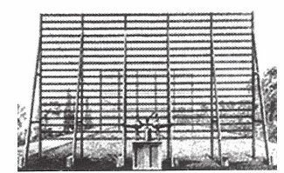
D After sending messages along his wires on the frame, he developed another version in which the wires were enclosed in glass tubes buried in the ground. At each end of the line a clockwork mechanism turned synchronously revolving discs with letters on them. A frictional-electricity machine kept the wire continuously charged, while at each end two pith balls hung from the wire on silk threads, and since they were similarly charged from the wire they stayed apart. Ronalds's instrument was of real practical use, and the brilliant idea of using synchronously rotating discs, now employed in the Hughes printing apparatus，was entirely his own. The only defect in his invention was the comparative slowness with which a succession of symbols could be transmitted.

E With communications between London and Portsmouth in mind, he believed his telegraph would work over distances of 800km. In the same year, Ronalds wrote to offer his invention to the Admiralty. In fact, in 1806, Ralph Wedgwood submitted a telegraph based on frictional electricity to the Admiralty, but was told that the semaphore was sufficient for the country. In a pamphlet he suggested the establishment of a telegraph system with public offices in different centres. Francis Ronalds, in 1816, brought a similar telegraph of his invention to the notice of the Admiralty, and was politely informed that 'Telegraphs of any kind are now wholly unnecessary.' John Barrow, Secretary to the Admiralty, replied that "Telegraphs of any kind are now wholly unnecessary; and no other than the one now in use will be adopted." (The one in use was a semaphore system.) Only a year after the end of the Napoleonic Wars, the Admiralty saw no need for improved communications, even though the semaphore was usable only in daylight and good weather.

F After this disappointment, Ronalds set off for the continent. He travelled throughout Europe and the Eastern Mediterranean, taking notes, sketching and collecting scientific books between 1816 and 1823. He had begun collecting his large library of works on electricity and kindred subjects. The last activity formed the beginnings of the Ronalds Library, left in trust to the IEE (now the IET) after his death. In a small pamphlet published in 1823, Ronalds described his invention and listed some of its possible uses, "Why should not government govern at Portsmouth almost as promptly as in Downing Street? Why should our defaulters escape by default of our foggy climate? Let us have Electrical Conversazione offices communicating with each other all over the kingdom if we can." In 1825 he invented and patented a perspective tracing instrument， intended to facilitate drawing from nature, which he improved about 1828, and described in a work called 'Mechanical Perspective.' These instruments seem to be the only ones for which he took out patents.

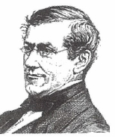
G However, Ronalds never patented his invention in electric telegraph. Ronalds seems to have made few or no practical contributions to science. In the meanwhile, one person did benefit from this work - Charles Wheatstone who saw the telegraph as a boy. When Charles Wheatstone was quite a child, his father had seen the Ronalds telegraph at work. Later, the invention of an electric telegraph had been marvelously developed by Wheatstone, who had seen many of the Hammersmith experiments, in conjunction with Mr. William Fothergill Cooke, and these two men together devised and patented in 1837 the first electric telegraph used publicly and commercially in England. When, in 1855, a controversy arose between Wheatstone and Cooke with regard to their respective shares in the invention, Wheatstone at once acknowledged his direct debt to Ronalds, and Cooke, though less fully, acknowledged the priority of Ronalds's work; Until 1855 Ronalds's share in the invention had been forgotten by the public.

H Early in 1843 Ronalds was made honorary director and superintendent of the Meteorological Observatory, which was then established at Kew by the British Association for the Advancement of Science. He began work on a system for registering meteorological data using photography and this time was awarded a grant to continue his work. A similar system was developed independently by Charles Brooke, aided like Ronalds by grants from the Royal Society, had invented independently about this time. But the British Association confirmed Ronalds's priority. This was the beginning of automatic, accurate recording of meteorological data and remained in use for some years after Ronalds's death.

I Ronalds lived long enough to see his prophecies come to fruition and to receive belated official recognition: in 1870, three years before he died, he was knighted by Queen Elizabeth I，for his "early and remarkable labours in telegraphic investigations."

Question 27-31
matching the each correct year to the historical event in the passage, and write the correct Answer into box of 27-31 in the answer sheet

A 1753 B 1806 C 1816 D 1823
E 1825 F 1837 G 1843

27 When did Francis Ronalds achieve a satisfactory result in the electricity experiment conducted first time
28 When was the first proposal of an electric telegraph based on static electricity
29 When did Ronalds get patent of his invention firstly
30 Ronalds first made it known and revealed the applicable significance of his telegram to public.
31 The contribution being done by Ronalds' invention in meteorological data

Question 32-35
Answer the questions below.
Choose NO MORE THAN FOUR WORDS AND/OR A NUMBER from the passage for each answer. Write your answers in boxes 32-35 on your answer sheet.

32 What were carved in the experimental dials when doing Ronalds' experiment his in garden?
33 What were enclosed with the buried telegram wires when Ronalds did the improved experiment?
34 What is the greatest distance Ronalds believed his telegram can send?
35 What kind of power supplied to keeping the wire charged continuously?

Question 36-40
The passage has paragraphs as A-I, which paragraph contains the following information? Write the appropriate letter A-I for box 36-40 on your answer sheet.
36 There is a commercial use of the telegram.
37 There is a contributory influence on Ronalds from a fellow he got to know.
38 Ronalds's proposal was rejected as the preceding reference to another application.
39 There existed a drawback of Ronalds's telegram.
40 Ronalds's contribution in telegraphic investigations was recoginised by authority.

This page is intentionally left blank.
WRITING
WRITING TASK 1
You should spend about 20 minutes on this task.

The diagram below shows the recycling process of plastics.
Summarise the information by selecting and reporting the main features, and make comparisons where relevant.

Write at least 150 words.
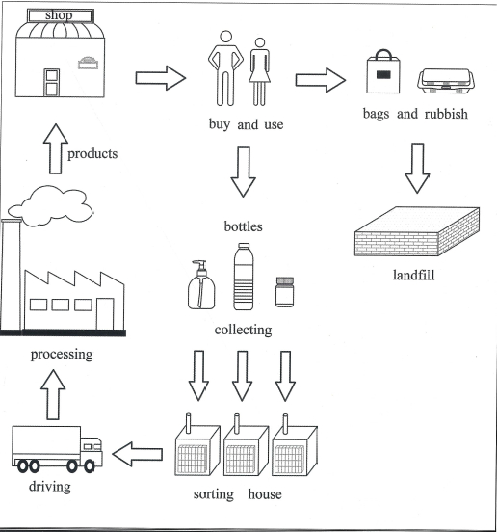

WRITING TASK 2
You should spend about 40 minutes on this task.

Write about the following topics:
Some people think that computers and the Internet are more important for a child’s education than going to school. Others believe that schools and teachers are essential for children to learn effectively.
Discuss both views and give your own opinion.

Give reasons for your answer and include any relevant examples from your own knowledge or experience.

Write at least 250 words.

